Lab Assignment 2.5– AI Assisted Coding
Ganesh
2303A51358
Batch:20

Task 1: Refactoring Odd/Even Logic (List Version)
Prompt Used: “Write a Python program to calculate the sum of odd and even numbers in a list. Use basic loops and conditional statements”
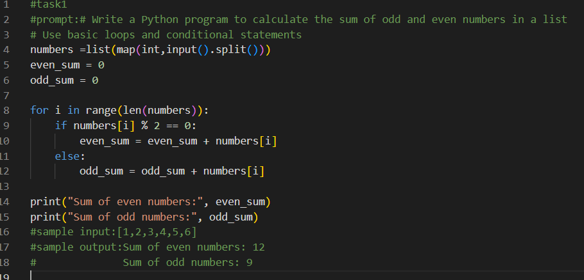

After Refactoring
Prompt Used: Refactor this code to improve readability and efficiency
Remove unnecessary loops and indexing. Use a cleaner and more Pythonic approach
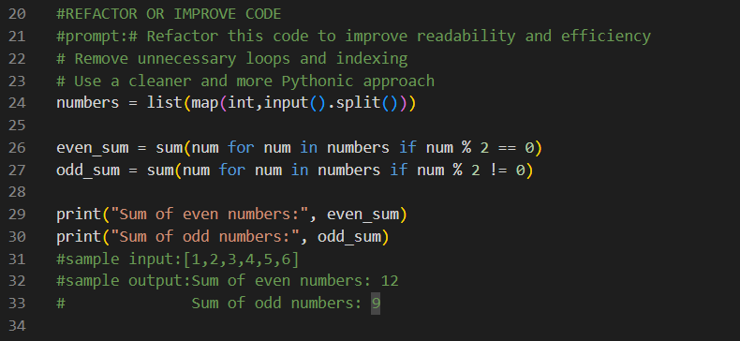
Expected Output Explanation

The original code uses a loop and indexing to calculate the sums. The improved code removes unnecessary indexing and uses Python’s sum() function with conditions, making the code shorter, cleaner, and easier to read.

Observation
Refactored code is more readable and efficient while producing the same result

Task 2: Efficiency & Logic Optimization (Readability Improvement)

Original Code:
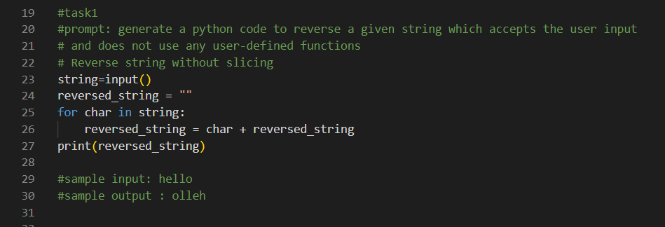

Prompt Used: “Simplify this string reversal code”

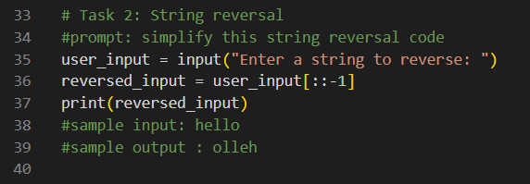
Expected Output Explanation
The original code reverses the string using a loop and an extra variable. It works, but it is a little long and harder to read.
The optimized code uses slicing to reverse the string in one line. This makes the code shorter, cleaner, and easier to understand.
Observation
GitHub Copilot gives correct code. When we ask it to optimize, it gives a better and simpler solution. AI helps in coding, but we should always check the code.

Task 3: Modular Design Using AI Assistance (String Reversal Using Functions)
Prompt Used: “Write a Python function to reverse a string with comments”
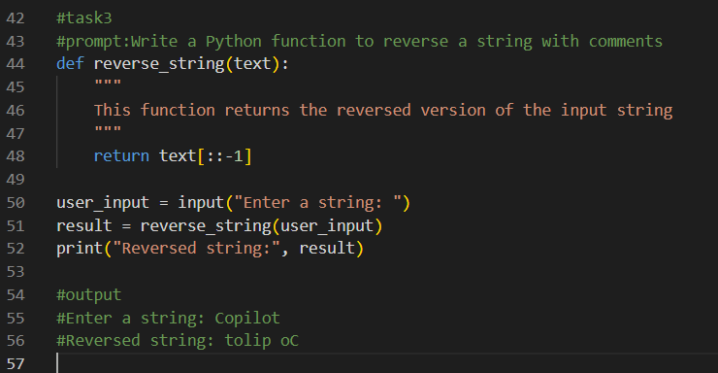

Expected Output Explanation
The function reverse_string() takes a string as input and returns the reversed string using slicing. The main program calls this function and prints the result. Comments are added to explain what the function does.

Observation
Using a function makes the code easy to reuse, easy to understand, and easy to maintain. GitHub Copilot correctly generated a clean and readable function when given a clear prompt.

Task 4: Comparative Analysis – Procedural vs Modular Approach (With vs Without Functions)

Comparison Table
Aspect | Without Functions (Procedural) | With Functions (Modular)
Code Clarity | Logic is mixed in main code | Code is well organized
Reusability | Cannot be reused easily | Can be reused anywhere
Debugging Ease | Debugging is harder | Debugging is easier
Large-Scale Use | Not suitable | Suitable

Short Analytical Report

The procedural approach without functions is simple and easy to write for small programs. However, the code becomes difficult to manage and reuse as the program grows.

The modular approach using functions improves clarity and reusability. It makes debugging easier and is more suitable for large-scale applications. Therefore, using functions is the better design choice for real-world and collaborative software development.

Conclusion

Function-based (modular) programming is preferred over procedural programming for clean, reusable, and maintainable code.

Task 5: AI-Generated Iterative vs Recursive Fibonacci Approaches (Different Algorithmic Approaches to String Reversal)
Prompt Used: “Write a Python program to reverse a string using a loop.Take input from the user. Do not use built-in functions or slicing. Implement logic in the main program”

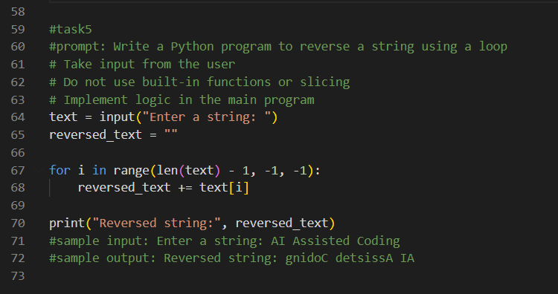

Comparison
- Execution Flow:
Loop-based method reverses the string step by step.
Slicing method reverses the string in one line.
- Time Complexity:
Both methods have O(n) time complexity.
- Performance for Large Inputs:
Slicing is faster because it is internally optimized in Python.
- When to Use:
Loop-based method is good for learning logic.
Slicing method is better for real applications.

Observation
GitHub Copilot can generate different correct solutions, and choosing the best one depends on readability and performance.

